Gale Presents: Udemy
Blog
Primary Audience: General public
How to Use: (1) Customize the copy as needed. (2) Hyperlink to the resource on your library’s website. Shorten the link with bit.ly, if needed. (3) Copy and paste the copy into your blog. (4) Proof and ensure hyperlink works. (5) Post.

Stay Ahead of the Learning Curve
Did you know studies show that, on average, workers change jobs 12 times in their lifetime?* That’s why it’s important to stay competitive. But how do you learn new technologies and keep up with a full-time job? The solution is Gale Presents: Udemy.
With this online learning platform, users can explore thousands of continuously updated, on-demand video courses across 75 categories in business, technology, design, and more to learn anytime, anywhere. All courses are taught by world-class instructors and, best of all, you can feel good knowing that the content is fresh. Courses are updated or replaced monthly with new material on emerging topics, so learners develop skills in the most relevant, in-demand areas.

Give Yourself Some “Me Time”
Work-life balance hasn’t been overlooked in this content collection. Discover hundreds of courses for personal enrichment, whether it’s learning a new language, tapping into your creative side, or exploring ways to be happy and healthy.
How to Get Started
All it takes is a library card to gain access to thousands of online courses. With this resource’s intuitive platform, finding the right course is easy. You can filter search results by course features, competency level, duration, topic, and ratings—and pave your own learning journey. You can also see top courses and trending skills. Plus, smart recommendations provide you with suggested courses based on the previous interactions you’ve had with the platform. When courses are completed, you can download a certificate of course completion.
Preview a Course
Before enrolling, users can review key information about a course, its instructor(s), and read student reviews on the course landing page. Every Gale Presents: Udemy course offers lecture videos the instructor has selected for preview, allowing you to sample the course content and the instructor’s teaching style. Take a look at this example.
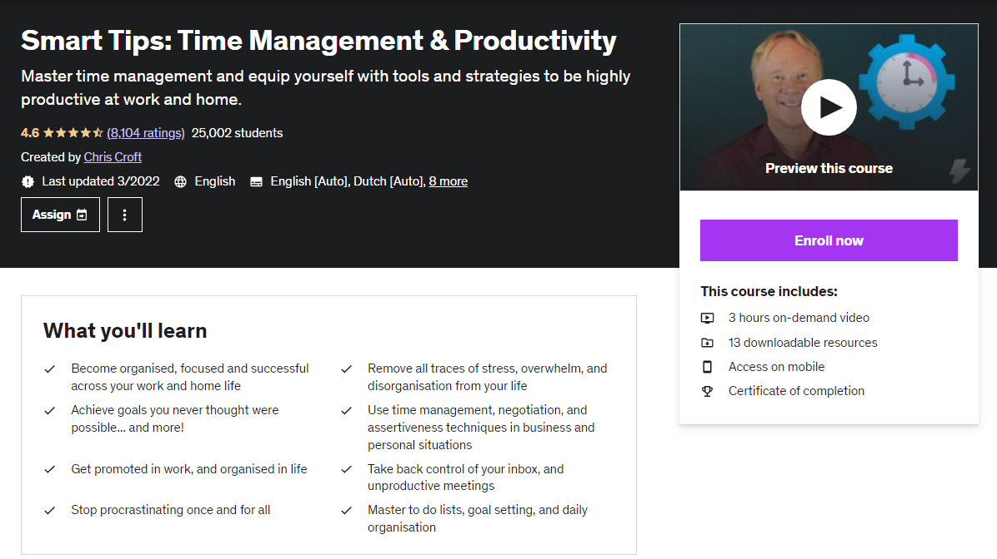

The employment landscape may be continuously changing, but you can keep up with it. Learn anywhere, at any time, with Gale Presents: Udemy—on-demand learning for in-demand skills. Enroll today! [LINK TO YOUR LIBRARY’S ACCESS]

*Bureau of Labor Statistics of the U.S. Department of Labor, “Number of Jobs, Labor Market Experience, Marital Status, and Health: Results from a National Longitudinal Survey,” news release no. USDL-21-1567, August 31, 2021.

